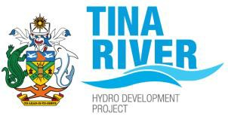
Job Advertisement – Project Accountant

We are hiring – Project Accountant

Join the Tina River Hydropower Development Project team in Honiara, Solomon Islands as the Project Accountant and be a part of a national project. This full-time position offers a 2-year contract with the potential for extension based on Project need.

Local candidates are encouraged to apply.

You will require at least a Diploma or Certificate in Accounting with a minimum 7 years of related work experience post qualification.

Refer to the Terms of Reference (TOR) for the role through the link provided or request it by emailing; office@tina-hydro.com.

Submit your application with a detailed Curriculum Vitae, application letter and supporting documents to:

The Permanent Secretary,
Ministry of Mines, Energy and Rural Electrification
P O Box G37, HONIARA, SOLOMON ISLANDS
Email: CVehe@mmere.gov.sb

Copy the Project Manager, Tina Hydropower Project Office at Level 2 Anthony Saru Building, HONIARA, SOLOMON ISLANDS
CC email: office@tina-hydro.com

Applications close on 4.30PM, 19 August 2026.

